### Project Design Phase - Part 2

### Cloud Deployment

|  |  |
| --- | --- |
| **NM ID** | **8073B6FD2C609D2A026419D64F1FD32** |
| **PROJECT TITTLE** | **BUILD IN EVENT MANAGEMENT USING SALESFORCE** |

* Cloud
* Hybrid
* On-premises or private cloud

Each of the cloud computing deployment models allows for a solution that provides you with different levels of control, flexibility, and management.

**Cloud**

A cloud-based application is fully deployed in the cloud. Applications in the cloud have either been created in the cloud or have been migrated from an existing on-premises infrastructure to take advantage of the benefits of cloud computing. Cloud-based applications can be built on low-level infrastructure pieces like file sharing and storage, or can use higher level services where you don’t need to worry about infrastructure management, architecting, and scaling requirements.

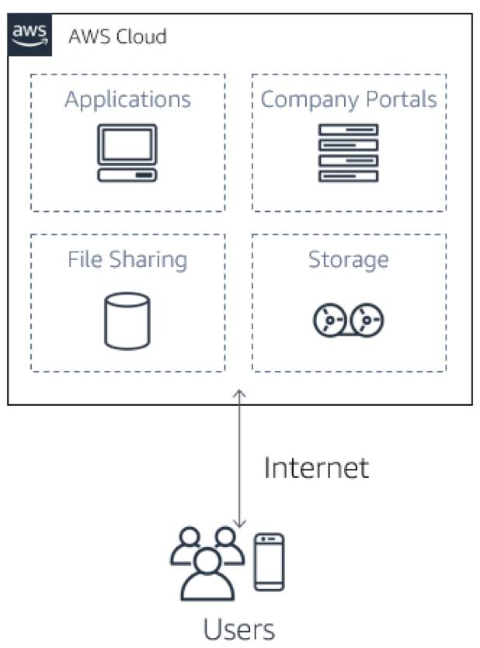

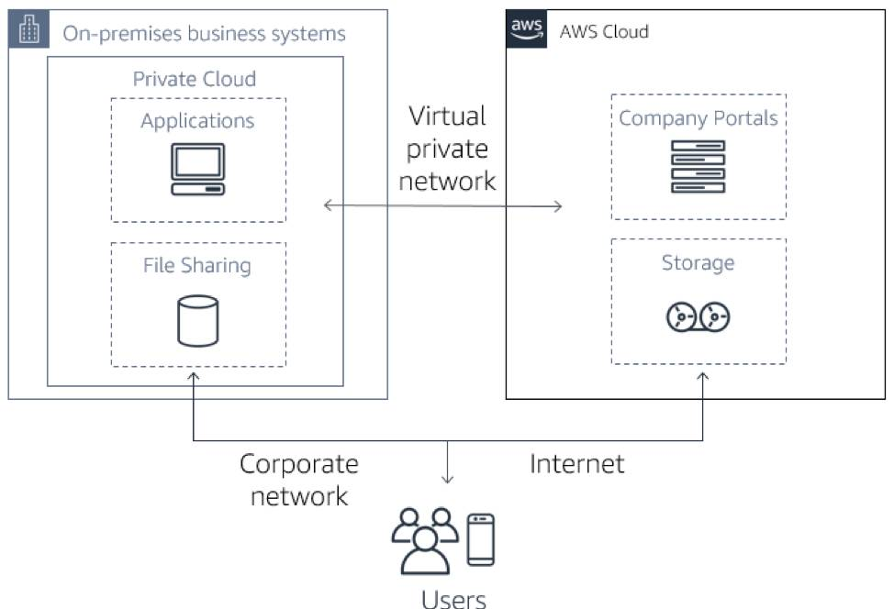

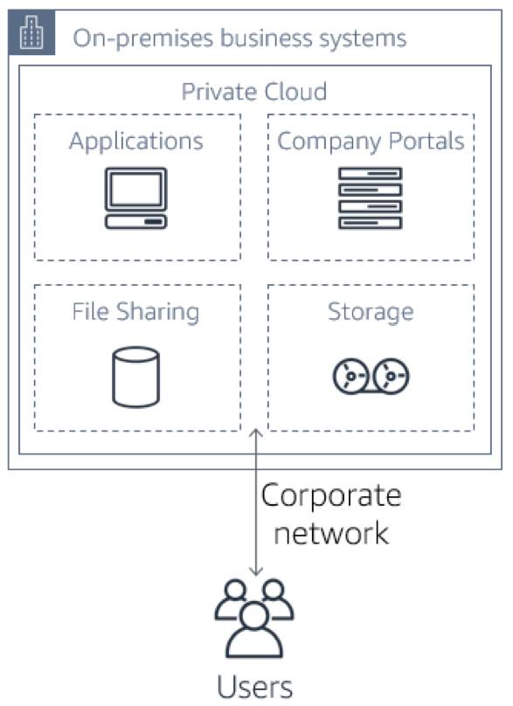

Top of Form













Bottom of Form